***Virginia Junior Classical League***

*presents this*

Certificate of Excellence

*to*

Graham Skrtic

*of*

Falls Church High School

*for*

*1st Place in Sight Latin*

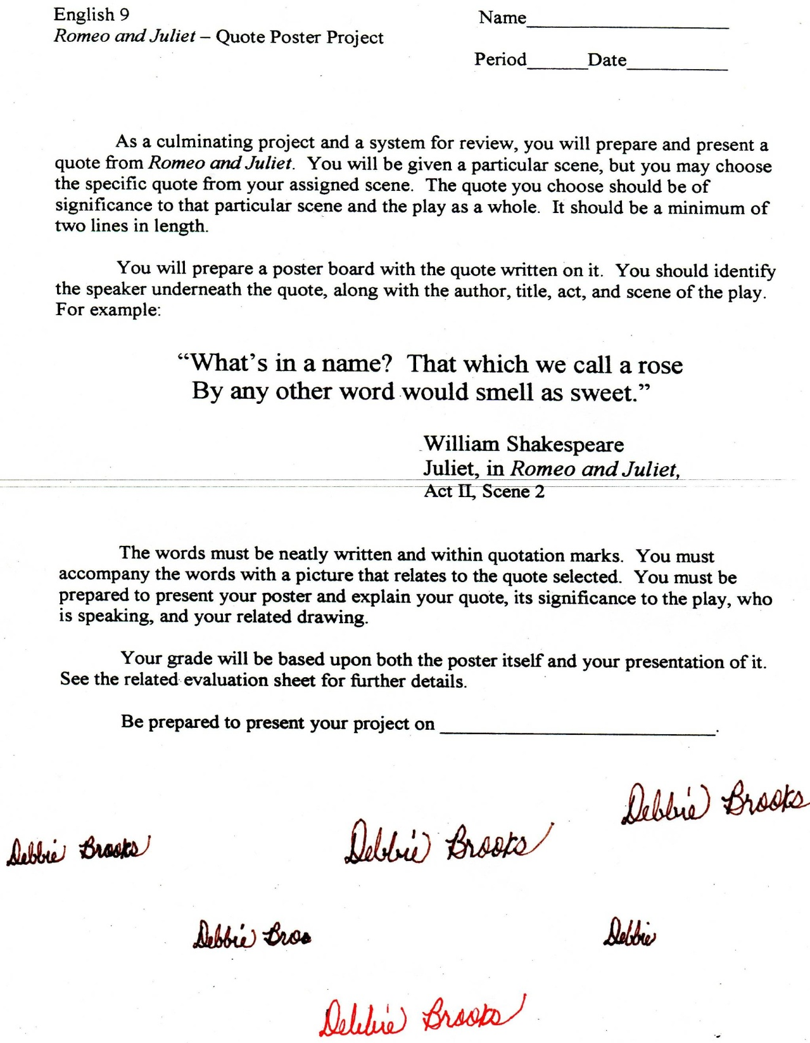

Microsoft Office Signature Line...

*a.d. viii Kal. Dec. MMDCCLXVII A.U.C. 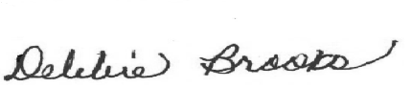*

***Virginia Junior Classical League***

*presents this*

Certificate of Excellence

*to*

Vanessa Avendano

*of*

Falls Church High School

*for*

*3rd Place in Mythology*

**

Microsoft Office Signature Line...

*a.d. viii Kal. Dec. MMDCCLXVII A.U.C. *

***Virginia Junior Classical League***

*presents this*

Certificate of Excellence

*to*

Graham Skrtic

*of*

Falls Church High School

*for*

*5th Place in Mottoes, Quotes, and Abbreviations*

**

Microsoft Office Signature Line...

*a.d. viii Kal. Dec. MMDCCLXVII A.U.C. *

***Virginia Junior Classical League***

*presents this*

Certificate of Excellence

*to*

Graham Skrtic

*of*

Falls Church High School

*for*

*6th Place in Grammar*

**

Microsoft Office Signature Line...

*a.d. viii Kal. Dec. MMDCCLXVII A.U.C. *

***Virginia Junior Classical League***

*presents this*

Certificate of Excellence

*to*

Dylan McElroy

*of*

Falls Church High School

*for*

*6th Place in Mythology*

**

Microsoft Office Signature Line...

*a.d. viii Kal. Dec. MMDCCLXVII A.U.C. *

***Virginia Junior Classical League***

*presents this*

Certificate of Excellence

*to*

Asher Berwick

*of*

Falls Church High School

*for*

*7th Place in Derivatives*

**

Microsoft Office Signature Line...

*a.d. viii Kal. Dec. MMDCCLXVII A.U.C. *

***Virginia Junior Classical League***

*presents this*

Certificate of Excellence

*to*

Graham Skrtic

*of*

Falls Church High School

*for*

*8th Place in*

**

Microsoft Office Signature Line...

*a.d. viii Kal. Dec. MMDCCLXVII A.U.C. *

***Virginia Junior Classical League***

*presents this*

Certificate of Excellence

*to*

Graham Skrtic

*of*

Falls Church High School

*for*

*8th Place in Reading Comprehension*

**

Microsoft Office Signature Line...

*a.d. viii Kal. Dec. MMDCCLXVII A.U.C. *

***Virginia Junior Classical League***

*presents this*

Certificate of Excellence

*to*

Graham Skrtic

*of*

Falls Church High School

*for*

*9th Place in Derivatives*

**

Microsoft Office Signature Line...

*a.d. viii Kal. Dec. MMDCCLXVII A.U.C. *

***Virginia Junior Classical League***

*presents this*

Certificate of Excellence

*to*

Dylan McElroy

*of*

Falls Church High School

*for*

*9th Place in History*

**

Microsoft Office Signature Line...

*a.d. viii Kal. Dec. MMDCCLXVII A.U.C. *

***Virginia Junior Classical League***

*presents this*

Certificate of Excellence

*to*

Abby Page

*of*

Falls Church High School

*for*

*10th Place in Mythology*

**

Microsoft Office Signature Line...

*a.d. viii Kal. Dec. MMDCCLXVII A.U.C. *